Defect Reporting

Module Name: E-Commerce Website - Cart, Checkout & Login Modules
Test Case ID: TC-CART-CHECKOUT-01
Tester Name: Chouhan Himansu Raj singh

Test Scenarios :

- Scenario ID: 1a
Scenario: Login with valid username and password
Test Steps:
1. Open the login page
2. Enter Username
3. Enter Password
4. Click Login
Screenshots: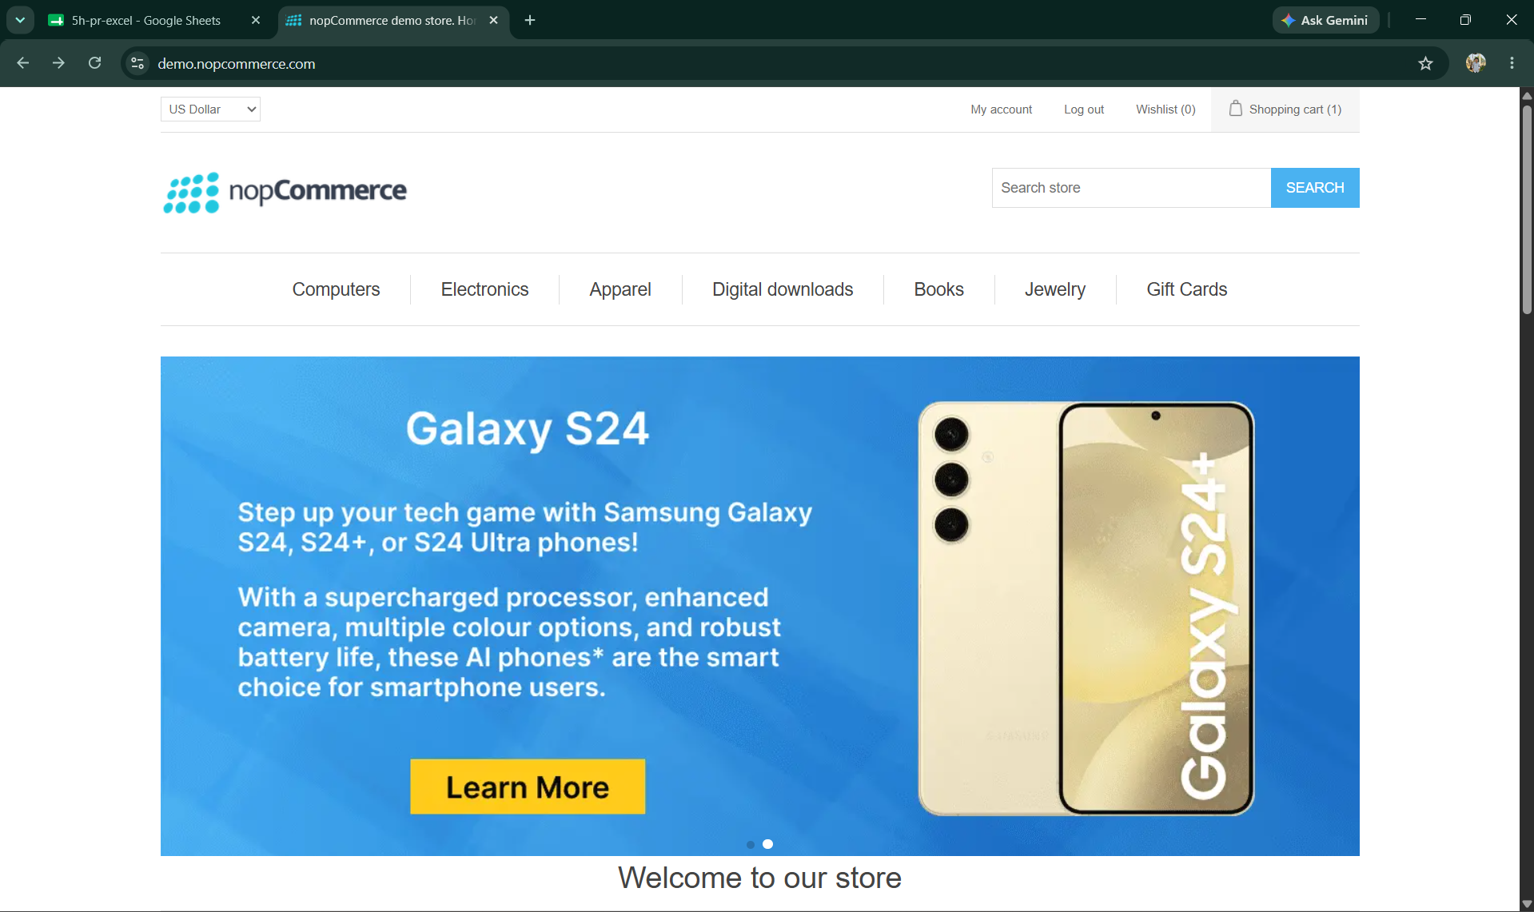

- Scenario ID: 1b
Scenario: Login with valid username, incorrect password
Test Steps:
1. Open the login page
2. Enter Username
3. Enter incorrect Password
4. Click Login

Screenshots: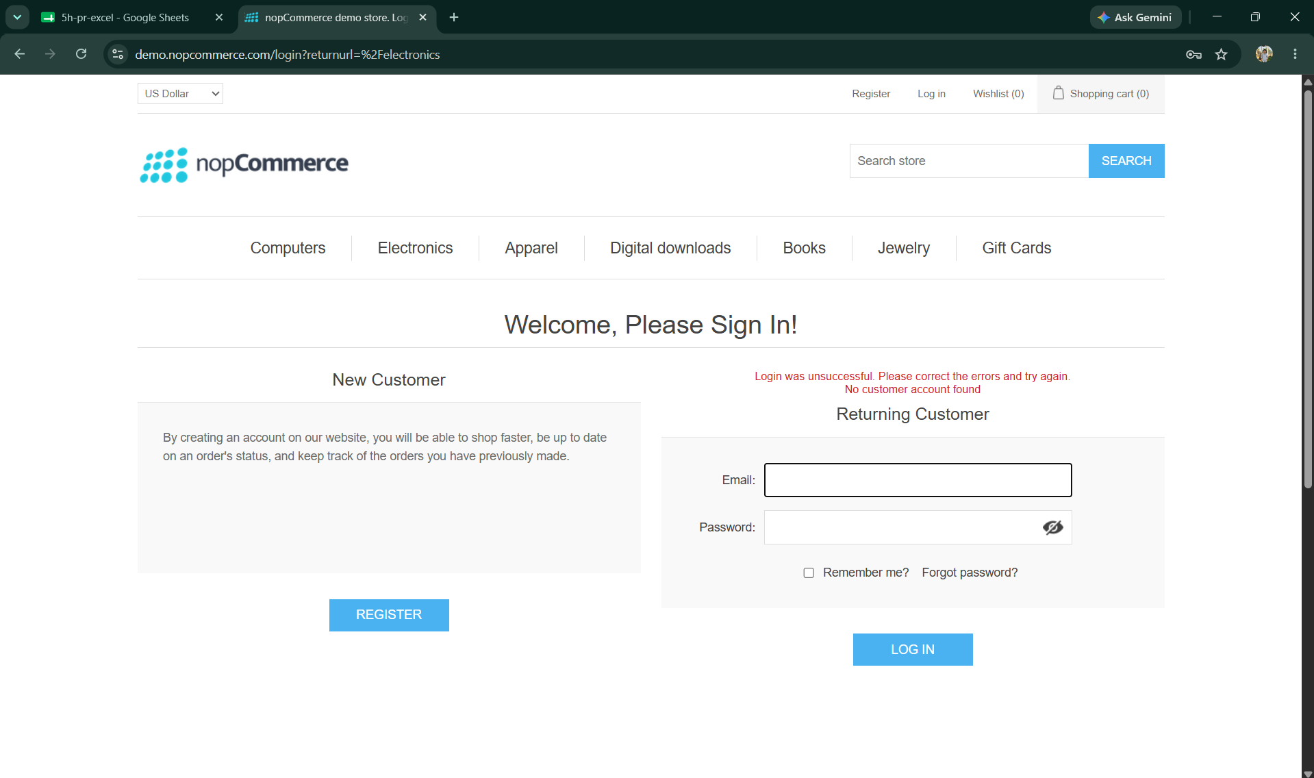

- Scenario ID: 1c
Scenario: Login with blank username field
Test Steps:
1. Open the login page
2. Leave Username blank
3. Enter Password
4. Click Login

Screenshots: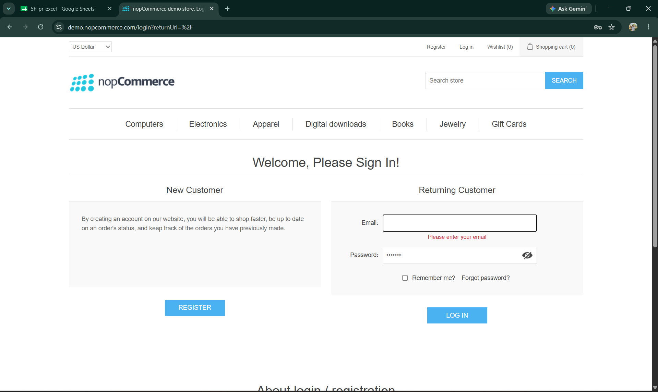

- Scenario ID: 1d
Scenario: Add to Cart with valid quantity
Test Steps:
1. Open Product Page
2. Select product
3. Enter quantity
4. Click Add to Cart
Screenshots: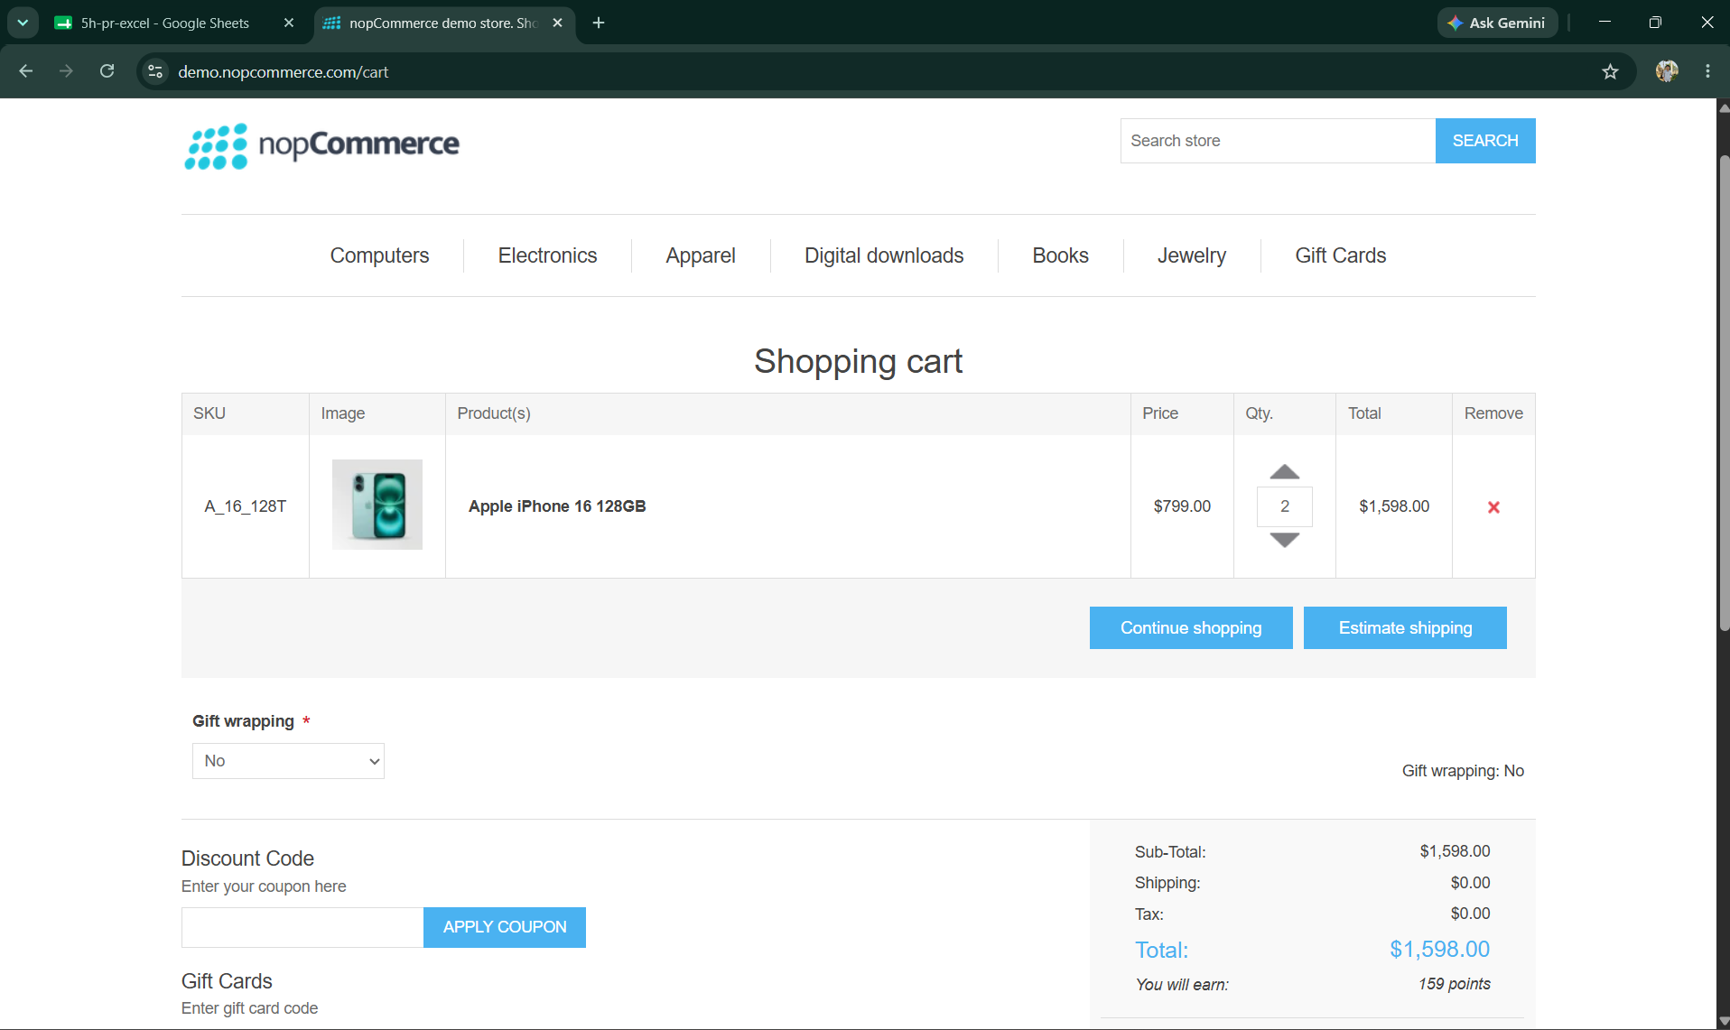

- Scenario ID: 1e
Scenario: Add to Cart with zero quantity
Test Steps:
1. Open Product Page
2. Select product
3. Set quantity to 0
4. Click Add to Cart
Screenshots:
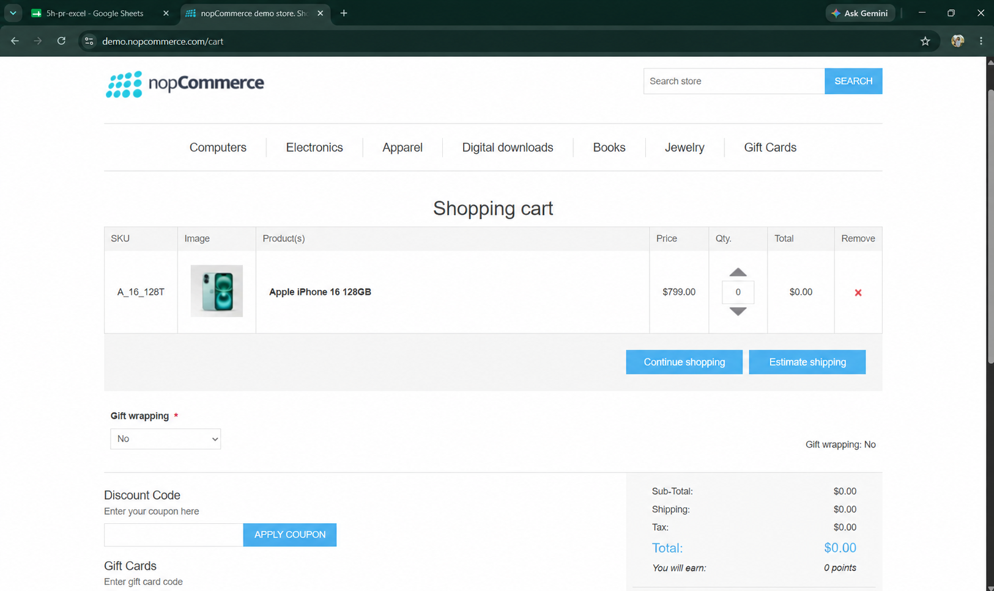

- Scenario ID: 1f
Scenario: Add to Cart with negative quantity
Test Steps:
1. Open Product Page
2. Select product
3. Set quantity to -1
4. Click Add to Cart
Screenshots: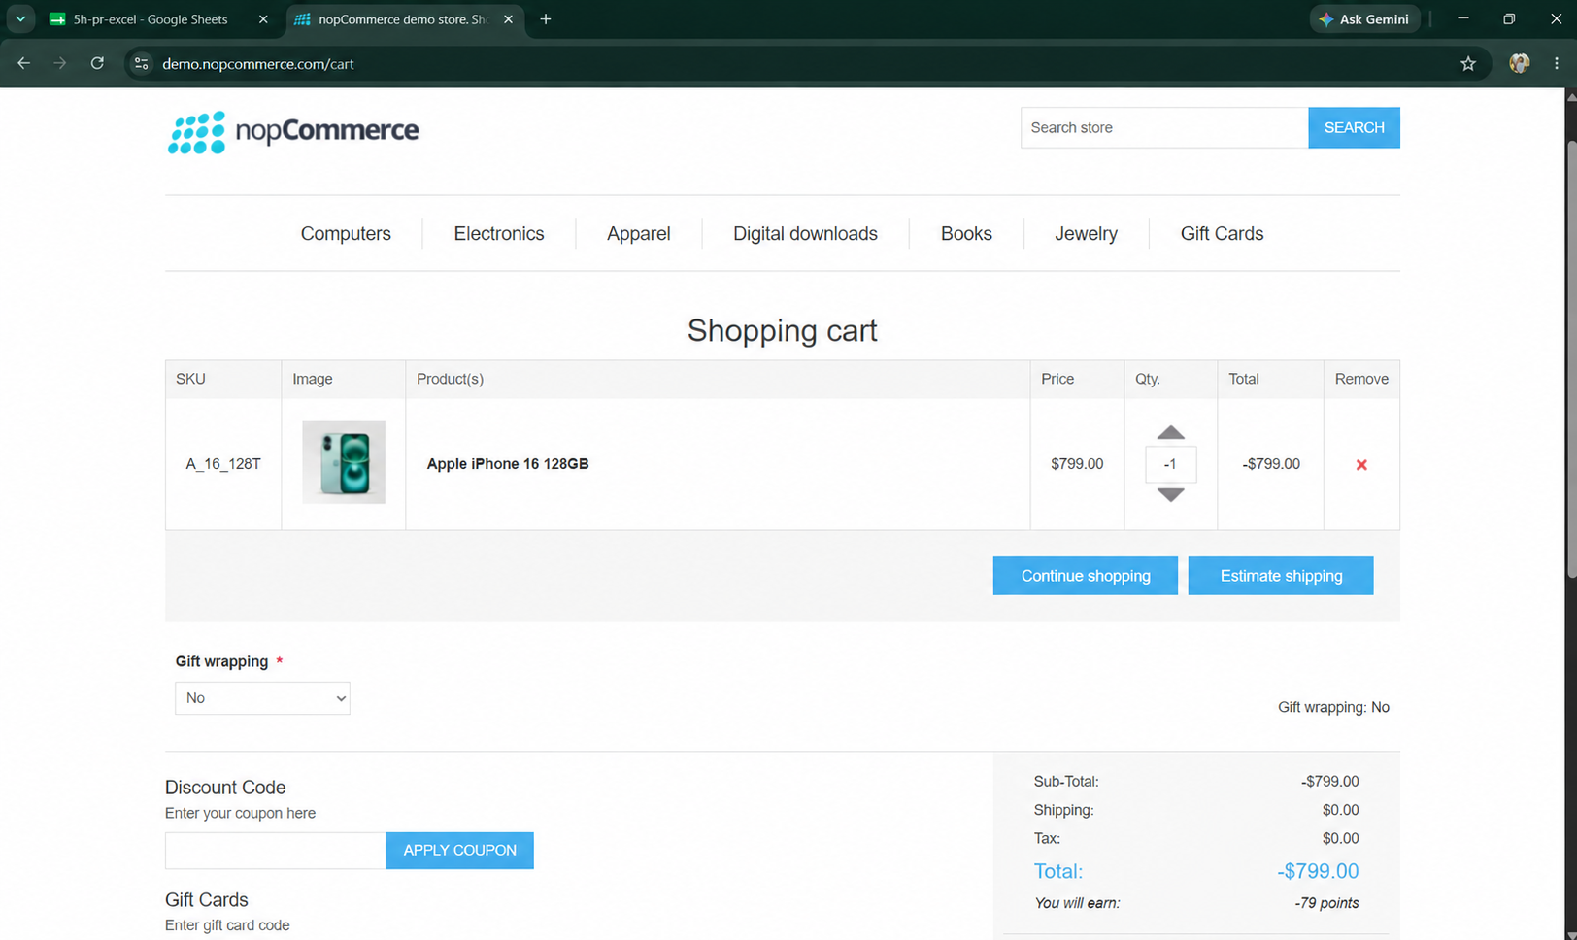

- Scenario ID: 1g
Scenario: Cart total calculation for valid items
Test Steps:
1. Add product to cart
2. Open Cart page
3. Verify total shown
Screenshots:

- Scenario ID: 1h
Scenario: Cart total recalculation after quantity update
Test Steps:
1. Add product to cart
2. Update quantity on Cart page
3. Click Update Cart
4. Verify total
Screenshots: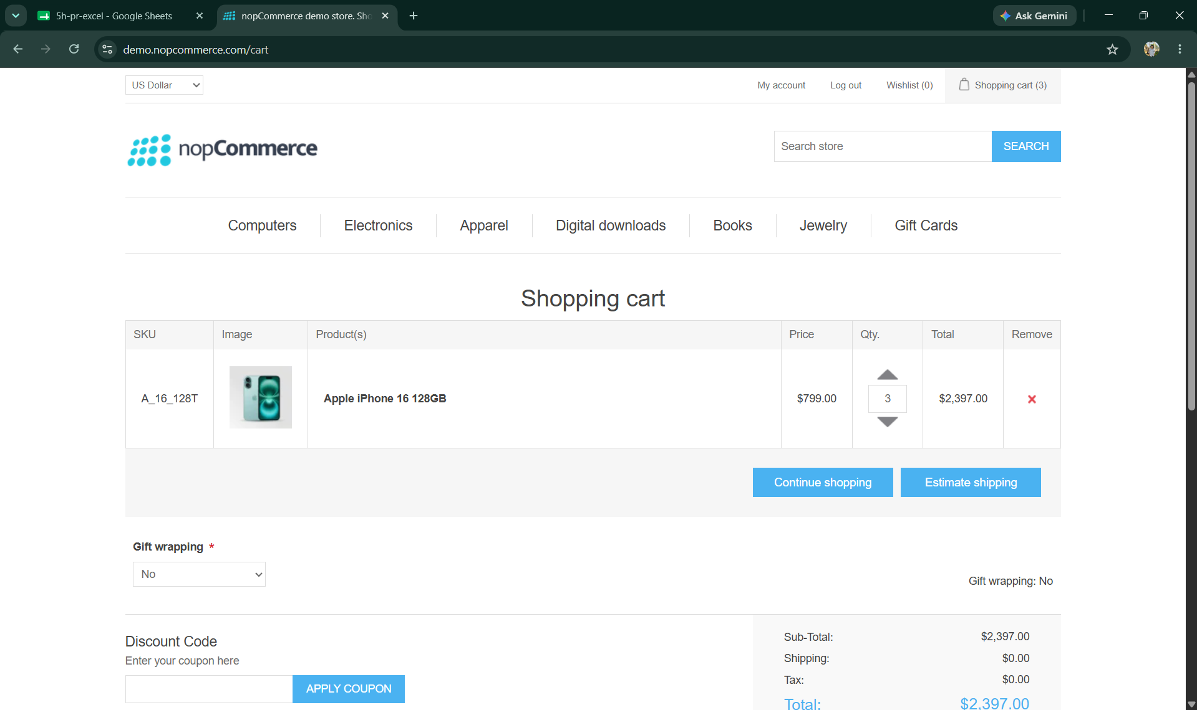

- Scenario ID: 1i
Scenario: Checkout with empty cart
Test Steps:
1. Ensure cart is empty
2. Navigate to Checkout page
3. Click Proceed to Checkout
Screenshots:
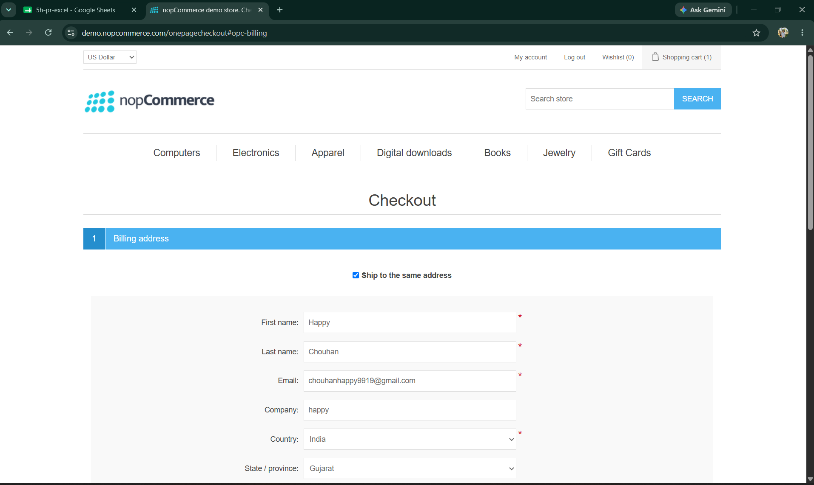

Summary of Test Results
Total Test Cases : 10
Passed : 10
Failed : 0
Not Executed : 0
Pass Rate (%) 100%

Conclusion and Recommendations

Conclusion
A total of 9 test scenarios were executed for the E-Commerce Website Cart, Checkout and Login modules. 5 tests passed and 4 tests failed, resulting in a 55.56% pass rate. Login and valid cart operations worked as expected, while quantity validation, cart-total recalculation, and empty-cart checkout defects were identified. The application should not be considered fully ready for production until the failed scenarios are fixed and successfully retested.

Test Coverage Analysis
· Valid credential authentication – PASSED
· Invalid password handling – PASSED
· Blank username validation – PASSED
· Valid cart quantity handling – PASSED
· Zero quantity validation – FAILED
· Negative quantity validation – FAILED
· Cart total calculation – PASSED
· Cart total recalculation after quantity update – FAILED
· Empty-cart checkout prevention – FAILED

Recommendations
· Prevent zero and negative quantities from being added to the cart.
· Recalculate cart totals whenever quantity is updated.
· Block checkout when the cart is empty.
· Display clear validation messages for invalid quantities.
· Retest failed scenarios and perform regression testing after fixes.

Bug Reports
Defect | Related | Issue | Expected | Actual
BUG-101 – Invalid Quantity | Scenarios 1e, 1f | Zero and negative quantities can be added. | Invalid quantities should be rejected. | Items are added with invalid quantities.
Cart Total Defect | Scenario 1h | Cart total does not update after quantity changes. | Total should recalculate automatically. | Previous total remains unchanged.
BUG-102 – Empty Cart Checkout | Scenario 1i | Checkout is allowed with an empty cart. | Checkout should be blocked with an appropriate message. | Checkout proceeds successfully.

